TASK #01:

bits 16

org 100h

section .data

num1 db 10

num2 db 5

result_add db 0

result_sub db 0

section .text

main:

; Addition of num1 and num2

mov al, [num1]

add al, [num2]

mov [result_add], al

; Subtraction of num1 and num2

mov al, [num1]

sub al, [num2]

mov [result_sub], al

; Terminate the program

mov ah, 4Ch

int 21h

TASK #02:

bits 16

org 100h

section .data

num1 db 10

num2 db 5

num3 db 3

num4 db 2

section .text

main:

; Add num1, num2, and num3

mov al, [num1]

add al, [num2]

add al, [num3]

; Subtract num4 from the sum

sub al, [num4]

; Store the result in BX register

mov bx, ax

; Terminate the program

mov ah, 4Ch

int 21h

TASK #03:

bits 16

org 100h

section .data

num1 db -10 ; num1 = 10

num2 db 5 ; num2 = 5

error_msg db 'Error: Negative number detected!', 0ah, 0dh, '$'

section .text

main:

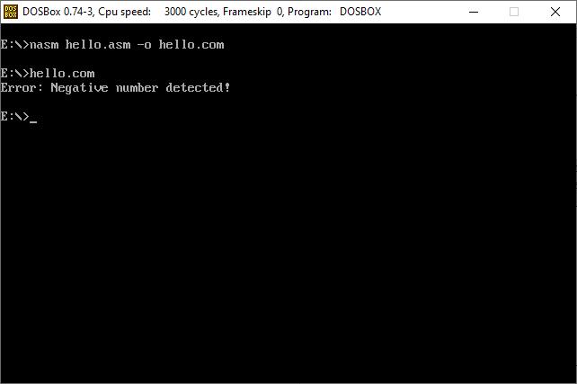 ; Check if num1 is negative

mov al, [num1]

test al, al

js error_handler

; Check if num2 is negative

mov al, [num2]

test al, al

js error_handler

; Perform addition of num1 and num2

mov al, [num1]

add al, [num2]

; Store the result in BX register

mov bx, ax

; Terminate the program

mov ah, 4Ch

int 21h

error_handler:

; Print error message

mov dx, error_msg

mov ah, 09h

int 21h

; Terminate the program after error message

mov ah, 4Ch

int 21h